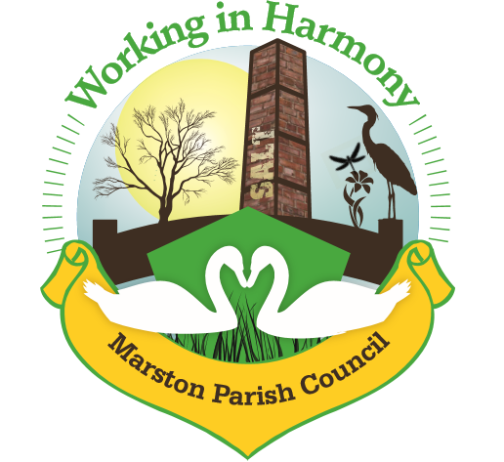
Minutes of Marston Annual Parish meeting held on 17th May 2023

The meeting opened at 18.30

Present:
Parish Councillors; Chair M Potts (MP), Phil Carter (PhC), Ian Stanley (IS), David Collier (DC), Amanda Nixon (AN), Margaret Peake (MPe) and Angela Johnson (AJ)

Clerk; Caroline Constable (CC)

- Welcome & Introductions from the Chair
Cllr MP welcomed everyone to the annual parish meeting, sadly no residents were present
- Apologies for Absence
There were no absences
- Review of the year
Chair MP thanked all cllr’s for their commitment over the past 12 months and officially welcomed cllr MPe to the council, a replacement for Julie Ledger who resigned earlier in the year. She noted the sad passing of Her Majesty Queen Elizabeth II and the accession and coronation of His Majesty King Charles III. Listing our achievements, particularly the installation of the defibrillator at the Church Hall, the removal of a post on the triangle and the clearing of footpath 7. Highlights of the past year included the late queen’s platinum jubilee afternoon tea, the afternoon tea for the coronation as well as hot pot lunches and our regular coffee mornings.
- Acceptance of Office for all councillors
Clerk ask all councillors to complete their acceptance of offers form and clerk countersigned. Declarations of interests forms were also filled in.
- Election of Chair & Vice-Chair
Clerk asked Cllr MP to vacate the chair position and asked Cllr PhC to take it temporarily in order to ask for nominations. Nominations were asked for the chair position, all cllrs voted unanimously for cllr MP to retake the chair and she accepted. Nominations for vice-chair were then taken and again all cllrs voted unanimously for cllr AN to retake the vice-chair and she accepted.
- Agreement of Standing Orders
2022 Standing Orders had been emailed to all cllrs for their perusal. Clerk had suggested that no changes were necessary and all in agreement. 2023 Standing Orders signed off my MP.
- Agree Minutes of last meeting 11/5/22
Minutes were agreed and signed
- Finance
2022/2023 Account Statement
Current Account receipts £17267.42 (including £13000 precept, £1486.26 rent, £1050.47 fundraising, £100 ward cllr grant towards platinum jubilee events)
Current Account payments £26522.27 (including £1857.60 for defibrillator, £1680 for cenotaph repair)
Starting balance 1/4/22 £9823.47
Closing balance 31/3/23 £4068.52
Business Reserve Account Interest £14.81
Starting balance £5477.77
Closing balance £3092.58 (£2500 moved to current account)
- Any other matters
No further business

Abbreviations: pc (parish council), cllr (councillor), cllrs’ (councillors), cllr’s (councillor’s), CW&C (Cheshire West and Chester), MM (Marston Murmurs)

