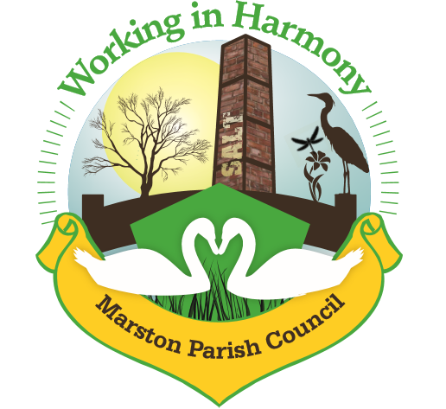
Minutes of Marston Annual Parish meeting held on 11th May 2022

The meeting opened at 18.25

Present:
Parish Councillors; Chairman M Potts (MP), Phil Carter (PhC), Ian Stanley (IS), David Collier (DC) and Angela Johnson (AJ)

Clerk; Caroline Constable (CC)

- Welcome & Introductions from the Chair
Cllr MP welcomed everyone to the annual parish meeting, sadly no residents were present
- Apologies for Absence
Cllr Julie Ledger (JL) had sent apologies via Cllr AJ, clerk reminded everyone that apologies should be sent directly to clerk. A reminder email would be sent out. Cllr AN sent apologies as she would be arriving late.
- Agree Minutes of last meeting 12/5/21
Minutes were agreed and signed
- Review of the year
Chair MP thanked all cllr’s for their commitment over the past 12 months and officially welcomed cllr JL to the council. She went on to highlight the replacement of the side door with a fire regulation emergency exit door, the new interactive traffic sign on Ollershaw Lane and the replacement of the hall carpet after a leak from one of the radiators. She commented on a return to regular use of the hall and that although footfall was much reduced than in previous years attendance at Remembrance Sunday and the MacMillan Coffee morning had been good (£290 had been raised). Changes had been made to the annual Front Gardens competition with the addition of several categories to highlight the many worthy gardens within the village. She also mentioned the transformation of the Heritage Fingerpost and the continued use of the ‘Keep their Memories Evergreen’ arch.
- Election of Chair & Vice-Chair
Clerk asked Cllr MP to vacate the chair position and asked Cllr PhC to take it temporarily in order to ask for nominations. Cllr AJ nominated cllr MP to continue as chair and cllr DC seconded it. Cllr IS then nominated cllr AN for vice-chair with cllr MP seconding it. Cllr’s completed their acceptance of office.
- Agreement of Standing Orders
A number of changes had been made to the standing orders, all of which were accepted and adopted as part of the new 2022 document.
- Finance
20212022 Account Statement
Current Account receipts £20712 (including £12000 precept, £4254 ward cllr’s grant for the interactive traffic sign, £1560 rent, £380 fundraising)
Current Account payments £26855 (including £3393 for fingerpost restoration, £6865 for carpark tarmac and £1460 emergency exit door)
Starting balance 1/4/21 £21630
Closing balance 31/3/22 £15487 (of which £8508 still to be paid for traffic sign)
Business Reserve Account Interest £0.87
Starting balance £10476.90
Closing balance £5477.77 (£5000 moved to current account)
- Any other matters

Abbreviations: pc (parish council), cllr (councillor), cllrs’ (councillors), cllr’s (councillor’s), CW&C (Cheshire West and Chester), MM (Marston Murmurs)

