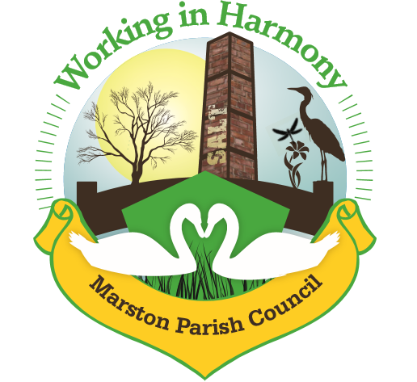
Minutes of Marston Parish Council meeting held on 9th February 2022

The meeting opened at 19:00

Present:
Parish Cllrs; Chairman M Potts (MP), Amanda Nixon (AN), Angela Johnson (AJ), Ian Stanley (IS) and Dave Collier (DC)

Clerk: Caroline Constable (CC)

Apologies:
Apologies received from Cllrs Phil Carter (PhC) and Julie Ledger (JL)

Declarations of interest:
There were no declarations of interest
Dispensations:
There were no dispensations
Public Forum:
There were no public present

Minutes:
The minutes from the parish council meeting of 12/01/2022 were agreed and approved.

Actions from previous meeting:

 | Action | Assigned to | Actioned
1 | Create an alert on planning system | CC | To be done
2 | Send letter to all residents surrounding higher marston play area regarding dogs | CC | √
3 | Contact CW&C - hedgerow at bottom of higher marston estate | CC | √. Need to chase as nothing done
4 | Contact Miles – look at outside lights | CC | √ Need to chase as he has been on holiday
5 | Contact CW&C – sign up to garden bin service | CC | √
6 | Contact Rev. Alec – cenotaph repair | MP | √
7 | Chase Fingerpost Contractor | IS | √
8 | Contact Zurich – insurance claim | CC | √
9 | Planning application 21/04717/FUL Tour&Store – object | CC | √
10 | Clerk to email details of Tour&Store application to Ward Cllrs to ask them to object | CC | √
11 | Email Ward Cllr LG asking for update on request for Bus service | CC | √
12 | Planning Application 21/04764/FUL & 21/04765/LBC – clerk to send comments | CC | √
13 | Contact Rev. Alec – upkeep of church yard | MP | √

 | Agenda Point | Assigned to..
1 | Parish Cllr Reports  Cllr MP – Rev. Alec attended coffee morning and stated he had been having trouble getting the community service team to commit to a restart date for maintenance of the church yard. He is to put more pressure on them. Hedges on Ollershaw Lane also overgrown and so need reporting. Clerk to action.  Cllr MP has been approached again by residents asking about plans for the Jubilee. So far only plans are for an Afternoon Tea on Sunday 5/6.  Cllr MP – Spring Litter Pick needs to be organised. Will discuss further at next meeting.  Cllr AN – still having problems with the heating. Clerk to contact heating engineer and get it checked out, it is due for a service.  Cllr MP – signed up to plant a tree for the Queen’s Platinum Jubilee. It was agreed that upto £100 could be spent on a mature tree to be planted in the church yard. Cllr MP to contact Rev. Alec to get permission. We would also need to put up a plaque which can be obtained from the Royal British Legion. Clerk to source | CC  CC  MP  CC
2 | Ward Cllr Reports  No ward cllrs present and no updates sent
3 | Progress Reports  - Interactive Traffic Speed Sign  Go ahead given to Highways just awaiting a date. Time frame was 12 weeks from ordering  - Cenotaph Repair  Contractor is still unobtainable. Rev. Alec is looking into getting the church’s stonemason on board with doing the work  - Heritage Signpost  Cllr IS contacted the contractor who has been recovering from surgery. He still plans to get it installed late February and is writing a piece for MM  - Neighbourhood Plan  Confirmation from CW&C that Wincham have formally pulled out of the joint plan. Marston plan now needs to be re-designated. Clerk to do asap  - Insurance Claim – leak  Claim complete and monies paid. Clerk to organise ordering and fitting of new carpet  - Higher Marston Play Area  All residents surrounding Higher Marston playa area were sent a letter stating problems with dogs being left unattended and asking that all dogs be supervised at all times. 3 residents responded querying whether they were being targeted specifically. Assured them that all residents had been contacted and no one was being targeted | CC  CC
4 | Finance  Invoices received & cheques created:  - Clerks Purchases and Expenses - £56.04  Clerks Salary 25.33 hrs @ £15.41ph - £390.39  Total payable £ 446.43 Chq no. 1321  Also payment for signing upto Green bin collection £40 and stamps of £39.60 (chq already issued no 1319)  - Itseeze website/email January 2022 - £57  - Williams Design & Print – newsletter £138.04 chq no.1324  - Waterplus – water bill from December 21 £20.03 taken 4/1/22  - NS&I statement – interest of £0.01 received  - HK Carpets - Deposit paid for new carpet of £1000 chq no. 1320  - WR Partners – 2021 Audit - £300 chq no. 1322  - Cleaner – 19/12/21-6/2/22 8 weeks £80  - Booking Agent –19/12/21-6/2/22 8 weeks £80  £160 to Angie chq no. 1323  - Rent:  - Penguin Group – 12/12 £20 6/1/22 £20 11/1 £20 17/1 £20 26/1 £20 31/1 £25 7/2 £20 + £17 = £162  - Julia Griffiths £17  - Graeme £25.50  £204.50 in total  - Coffee morning donations £52.04
5 | Correspondence  - Email from HyNet North West Hydrogen Pipeline about Consultation for North West Hydrogen Pipeline  - Email from CW&C about Community gardens & allotments  - Email from the Planning Inspectorate about development consent from Cadent Gas for Hydrogen Pipeline – Cllr AJ to attend a public meeting, it was agreed that comments could not be made until more information known  - Email from CW&C about rollout of new recycling and waste collection service  - Email from CHALC about new code of conduct format – clerk is to go through the new document and highlight any changes that may be needed and then update our documents as necessary  - Email from CW&C about the consultation on the hydrogen pipeline  - Email from CW&C clarifying the rollout of new recycling and waste collection service | AJ  CC
6 | Any other business  No further business

Confirmed date of next meeting, 09/03/22

Meeting closed at 20:20

Abbreviations: pc (parish council), cllr (councillor), cllrs (councillors), cllrs’ (councillors’), cllr’s (councillor’s), CW&C (Cheshire West and Chester), MM (Marston Murmurs), MPC (Marston Parish Council)

