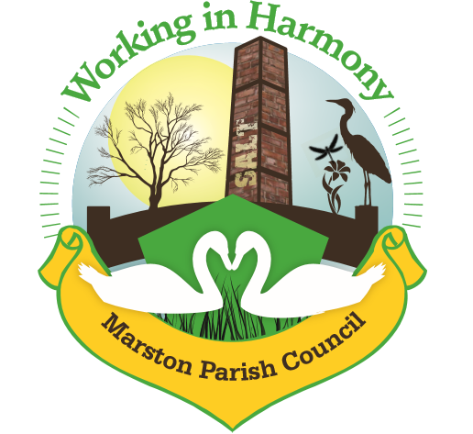
Minutes of Marston Parish Council meeting held on 13th January 2021
This meeting was held virtually using Google Meet
All councillors were sent an invitation email at 6.30pm with a link to ‘Join’ the meeting. Clerk ran the meeting and accepted all join requests
The meeting opened at 19:05
Present:
Parish Cllrs; Chairman M Potts (MP), Phil Carter (PhC), Amanda Nixon (AN), Dave Collier (DC) and Chris Anthwal (CA)
Ward Cllrs; Phil Marshall (PM)
Clerk; Caroline Constable (CC)
Apologies:
Apologies received from Wrd Cllrs Lynn Gibbon and Norman Wright
Declarations of interest:
There were no declarations of interest
Dispensations:
There were no dispensations
Public Forum:
There were no requests from the public to join the meeting

Minutes:
The minutes from the parish council meeting of 11/11/2020 were agreed and approved.

Actions from previous meeting:
Action list will recommence from next month

 | Agenda Point | Assigned to..
1 | Parish Cllr Reports  Cllr MP – noticed a workman working at the back of a property adjacent to the children’s play area on Higher Marston. The bollards put in place to stop vehicles accessing the area had been removed. When approached the workman said he was putting in a drive for the owner of the property and would then be putting one in for the next-door neighbour. The grass to the rear of the property had been removed to do the work and was looking messy. These properties are not supposed to have vehicular access. Cllr MP then returned with Cllr PC to take photographs at which point the workman said he had got it wrong and that the drive was not for a vehicle he also said that he would be replacing the grass and that the owner would be putting his trailer there. Cllr CA commented that only the properties to the left-hand side of the area (away from the play area) had vehicle access. Wrd Cllr PM stated that he would visit the area and look into the issue and then advise. | PM
2 | Ward Cllr Reports  Ward Cllr NW had contacted the clerk with an update as he was not certain whether he would be able to join the meeting as he had other meetings directly before and could not guarantee that he would be able to access the online meeting – he had news that the resurfacing of Ollershaw Lane from the last point of repair (near to the ‘Old Vicarage’) to the Salt Barge pub was in the pipeline. He could not however give a start date as this had not been scheduled.  Ward Cllr PM – commented that the state of the roads was a big community concern especially with loose grit and potholes. He suggested that we advertise the council app where issues could be accurately located with a ‘pin drop’. Clerk to add notice to next issue of MM and the website.  Environmental Strategy Consultation currently ongoing – residents are encouraged to highlight areas of wildlife that they come across. There is an interactive map where these locations can be marked. Marked areas will then be given consideration for future conservation and protection.  Informed that new central COVID vaccination centres were opening up. Ward Cllr LG will forward details.  A new central hub with contact numbers is being developed for the support of vulnerable people during the pandemic.  More business grants are available for businesses struggling due to lockdown. £2000 to £9000 is available to each business. Some has been allocated automatically but there is also a discretionary fund available.  Ward Grants: grants are still available for any small projects and should be applied for before the end of the month | CC
3 | Progress Reports  - Evergreen Arch – clerk asked what was happening with the storage/future use of the arch. It was confirmed that the arch has been dismantled and will be re-erected each year in the Church yard  - Cenotaph Repair – second quote now obtained (thanks to Tony Hayes) however, stone mason only suggesting repair of the flagstones and decorative surround. Clerk has sent the quote to the vicar for diocese records. It was agreed that the original repair agreed with Cheshire Stone Masons will go ahead. Clerk advised that they will start the work when the weather improves  - Painting of the church hall and tarmacking of car park – clerk has had no success with gaining quotes for any of the work. She asked whether cllrs would email any contacts that they might have. Cll CA said she had a contact and would email details. Clerk to try and obtain quotes | CA  ALL  CC
4 | Finance  - Clerk confirmed that signatory amendments had been finalised.  - Signing off of latest accounts – to 31/12/20 - Cllr MP checked and signed bank reconciliations  - Budget 2021-2022 presented to cllrs. After consideration budget agreed and Cllr MP signed off  Invoices received & cheques created:  - Clerks Purchases and Expenses - £136.15  Clerks Salary 45.33 @ £15.41ph - £698.59  Total payable £834.74 Chq no. 1266  - Scottish Power £190.31 taken 25/11/20  - Diocese of Chester Faculty Order for cenotaph repair £151 chq 1259 sent in dec 20  - Williams Design & Print Dec/Jan newsletter £122 chq 1264 sent in dec 20  - Receipt for material for evergreen arch £200 chq 1265 sent dec 20  - Scottish Power £242.79 taken 18/12/20  - Waterplus £22.17 taken 5/1/21  - Received £25 in November from A Hughes via online banking – this was confirmed to be payment for advertising in MM  - Itseeze payment £54 taken 23/11. Clerk advised that due to issues with email data limit size she had requested that the limit be increased at a cost of £2.50 + VAT per month. Cllrs agreed to this change. New monthly bill will be £57  - Vat repayment £270.55 received 21/12  Rent received (via Cllr CA):  No rent  Cleaner  10 weeks 8/11/20 – 10/1/21 £100  Invoices received from Bookings agent  10 weeks 8/11/20 – 10/1/21 £100  £200 chq to Cllr CA chq no. 1267  Payment of these services discussed in view of no bookings and the fact that the hall was not being cleaned every week. Clerk advised that it may be difficult to get a replacement if Angie was ‘let go’. Cllrs agreed to carry on payments. However payment would now be via cheque directly to Angie. Clerk to advise her of this | CC
5 | Correspondence  - Email from Robert Lester of CW&C planning regarding 20/02455/LDC (amendment of 19/03509/LDC) application for storage of building and materials at Crystal Cottage – including PC’s response to above  - Notification of Appeal – land to north west of Ollershaw Lane – against an enforcement notice for erection of 3 buildings – parish councils comments sent  - Email from Cllr Warren Davies – resignation – resignation accepted upon receipt of email. Mr Davies had sent an article which he wished to have published in MM, agreed to publish and clerk to add thanks for his contribution  - Planning Application 20/02546/FUL – duplication of a July application  - Notice of Decision 20/02546/FUL – Approval  - Email from resident regarding non response of a Ward Councillor – ward cllrs have been informed and an apology has been sent  - Notification of Appeal – 20/00759/FUL – erection of a cattle shed – comment deadline 19/1/21 – email requesting that discussion be left until Jan 21 meeting. Cllrs agreed to send comments based upon original objection. Clerk to send response  - Email from Tony Hayes regarding second quote from a stone mason with regards to cenotaph repairs – email forwarded onto Vicar  - Precept Request 2021/2022 – deadline 29/1/21. Precept discussed as part of budget. It was agreed to maintain last year’s request of £12000. Clerk to send request | CC  CC  CC
6 | Any other business  No other business

Confirmed date of next meeting, 10/02/21

Meeting closed at 19:46

Abbreviations: pc (parish council), cllr (councilor), cllrs’ (councillors’), cllr’s (councillor’s), CW&C (Cheshire West and Chester), MM (Marston Murmurs), MPC (Marston Parish Council)

