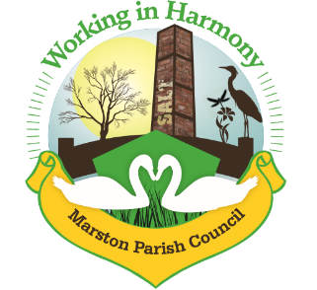

Marston Parish Council meeting 18th July 2018
Agenda

- Apologies for Absence: To receive apologies and approve reasons for absence.
- Declarations of interest: Register of interests - Councillors are reminded of the need to update their register of interests and the need to disclose both the type of interest and its nature.
- Dispensations: To consider requests for Dispensations.
- Public Forum: Electors and members of the public are welcome to raise their issues or present matters of interest to the council.
- Minutes:
To consider the approval of the minutes of the last meeting of the Council and a revised format for the minutes.
- Progress reports;
Hall working group - to discuss quotations for work required at the hall.
Events working group – To confirm the ‘Best Kept Garden’. Judging to take place on Sunday 19th August 2018 at 11.00am.
- Finance
To note rent received
To consider payments to be made as per attached list.
- Neighbourhood/Parish Plan
To note any meetings held and actions taken.
- Correspondence
To note correspondence received as per attached list.
- Ward Councillors reports (for information only – items raised for decision will appear on the agenda for the next meeting.

- Parish Councillors’ reports and items for future agendas
Each Councillor is requested to use this opportunity to report minor matters of information not included elsewhere on the agenda.
- Parish Council Surgery
To discuss.
- Bridge over the stream.
To note any update.
- The Newsletter.
To discuss any developments.
- The setting up of a ‘Church Hall Charitable Trust’
To discuss any developments
- The Salt Store/ Coronation Building.
To discuss any developments.
- The Avenue and the Area behind the Salt Barge.
To discuss any developments
- Traffic calming.
To discuss.
- Bus Service.
To discuss.
- Procedure to monitor planning applications.
To discuss.

Date of the next meeting. To confirm the date of the next Parish Council meeting which is scheduled for 12th September 2018.

